Japan Bowl 2021 Gestures Guide
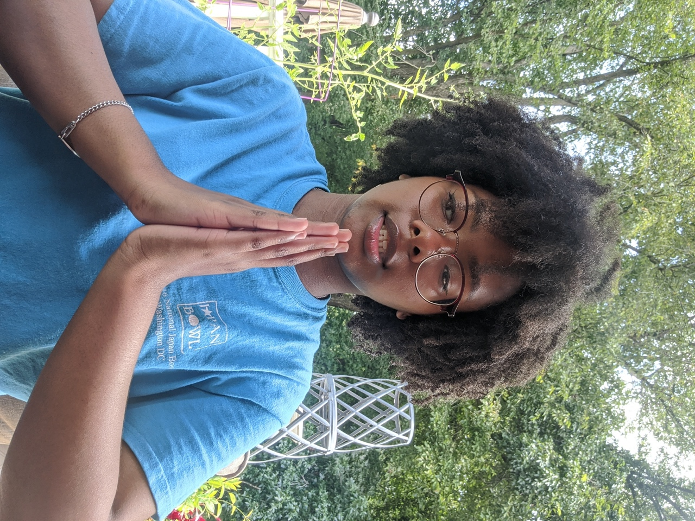
ごちそうさまでした。 - Thanks for the meal. (said after eating)

This gesture is performed by putting both hands together and saying “ごちそうさまでした”—slightly bowing the head and hands forward around the time of saying “そう” before returning the head and hands to their original positions. It is normally said after finishing the consummation of any food or beverage.

いただきます。- Thanks for the meal. (said before eating)

This gesture is performed by putting both hands together and saying “いただきます”—slightly bowing the head and hands forward around the time of saying “だき” before returning the head and hands to their original positions. It is normally said before the consummation of any food or beverage.

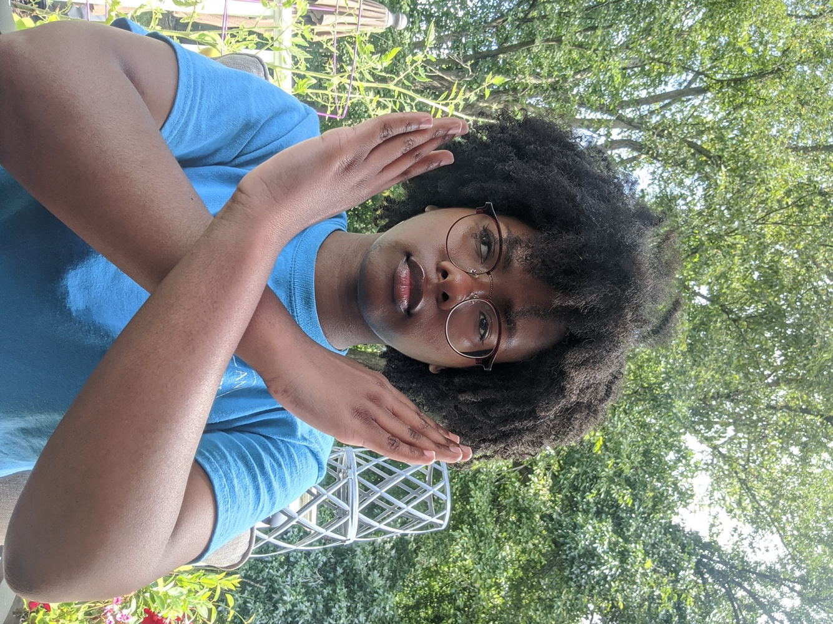
バツ - Wrong answer

This gesture is performed by crossing one arm over the other, left or right, jointed just below the wrist.

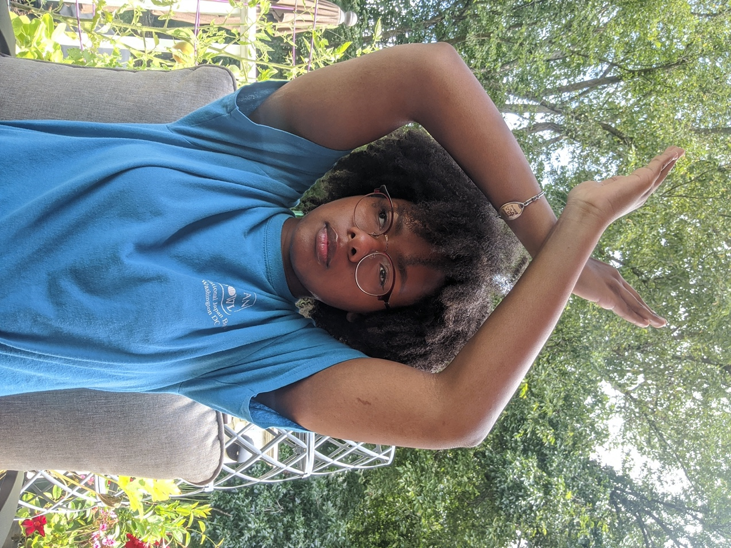
バツ - Wrong answer

This gesture is performed by raising both arms above the head, crossing one arm over the other, left or right, and jointing them just below the wrist.

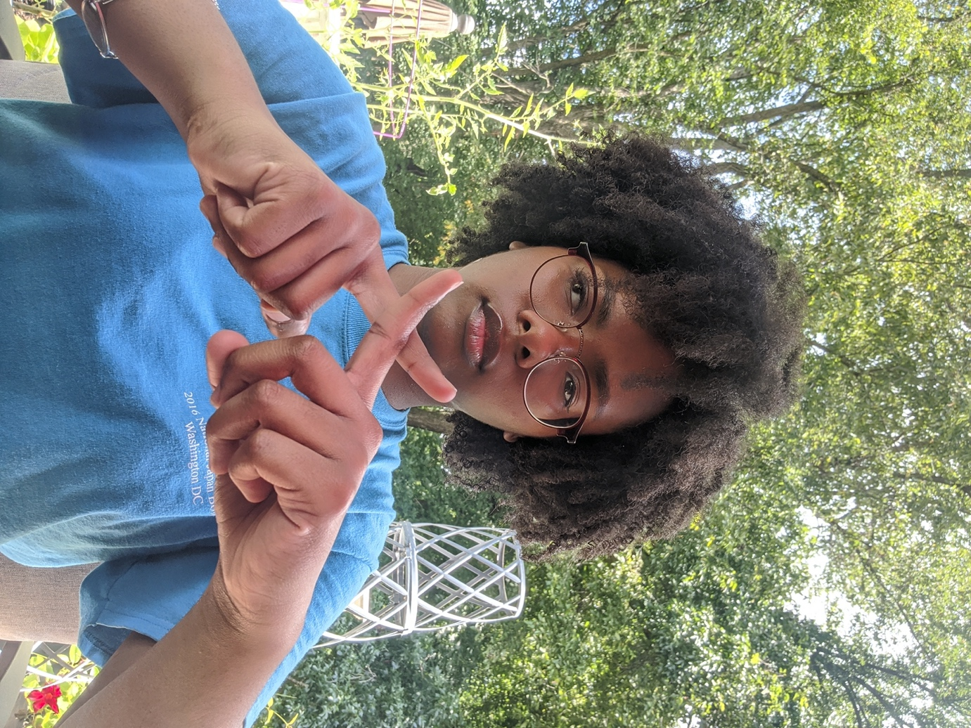
バツ - Wrong answer

This gesture is performed by crossing one index finger over the other, left or right, crossing at the middle joint.

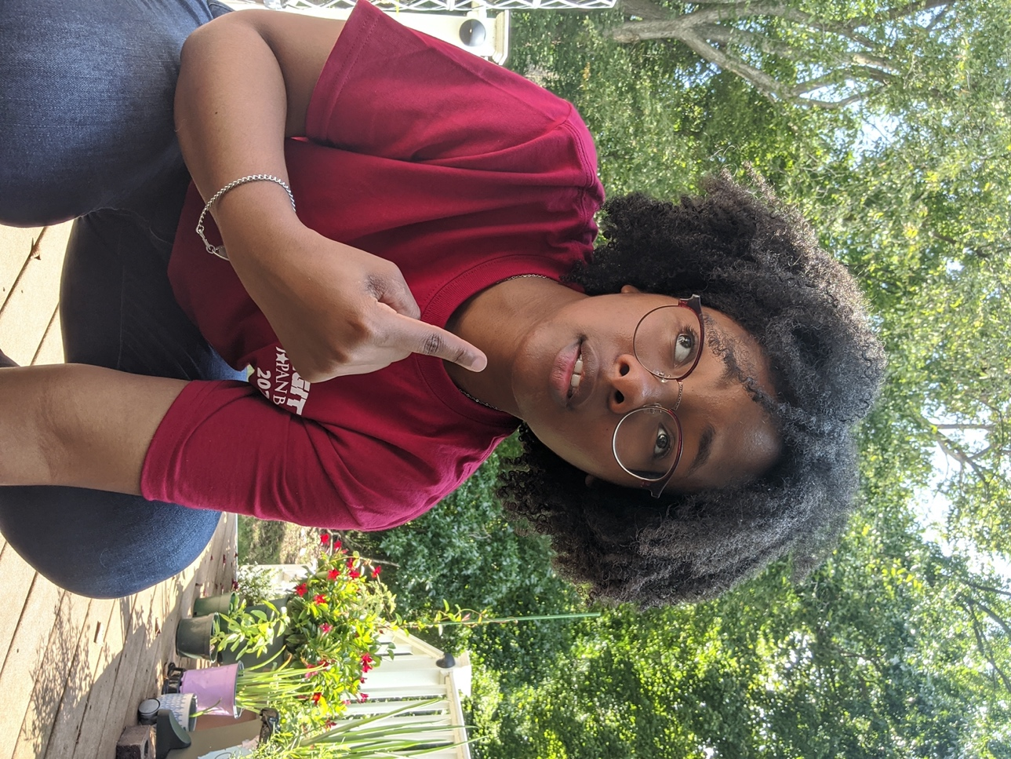
自分に指す - pointing to oneself

This gesture is performed my pointing the index finger, on either hand, at one’s face to indicate that an individual is speaking about themselves or inquiring if another person is talking about them.
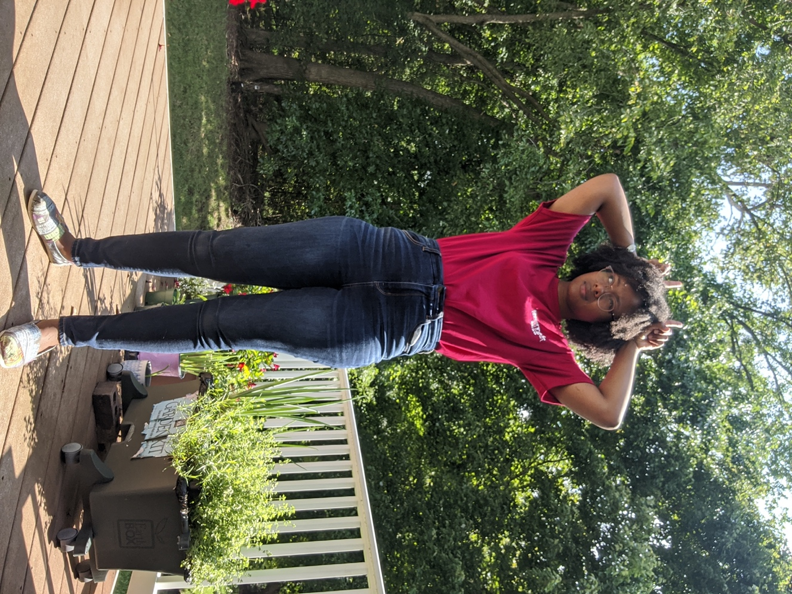
つねが出る - devil horns

This gesture is performed by closing all fingers on both hands except the index fingers and putting them on both sides of the head. This typically indicates the person is angry.

お辞儀 - bowing

This gesture is performed by putting both hands together below the waist, keeping the lower body still, and bowing the entire upper body from the waist forward. The deeper the bow, the more respect is shown. The picture shown demonstrates a shallower bow intended for more casual interactions whereas one may bow deeper when greeting a superior in the workplace, or even further completely parallel with the ground when giving a profuse apology.

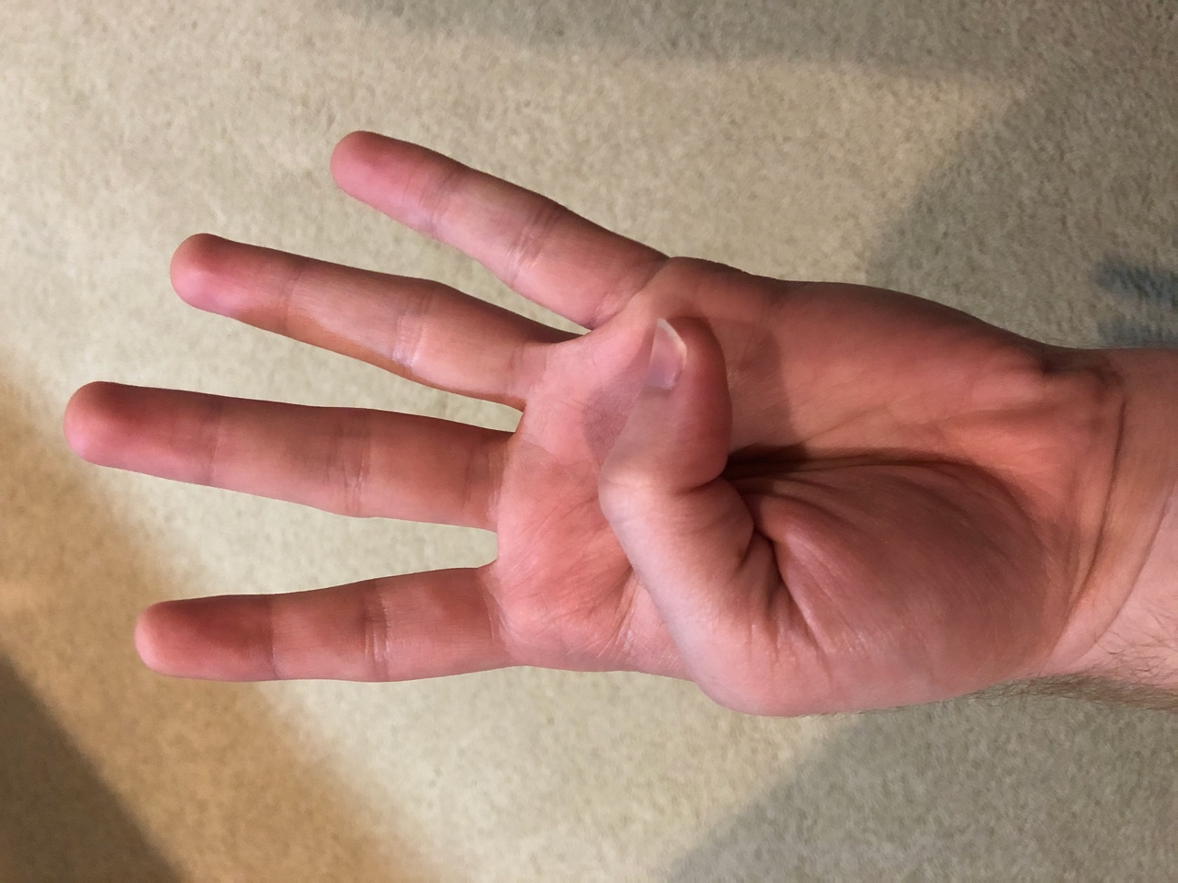
一 - 1
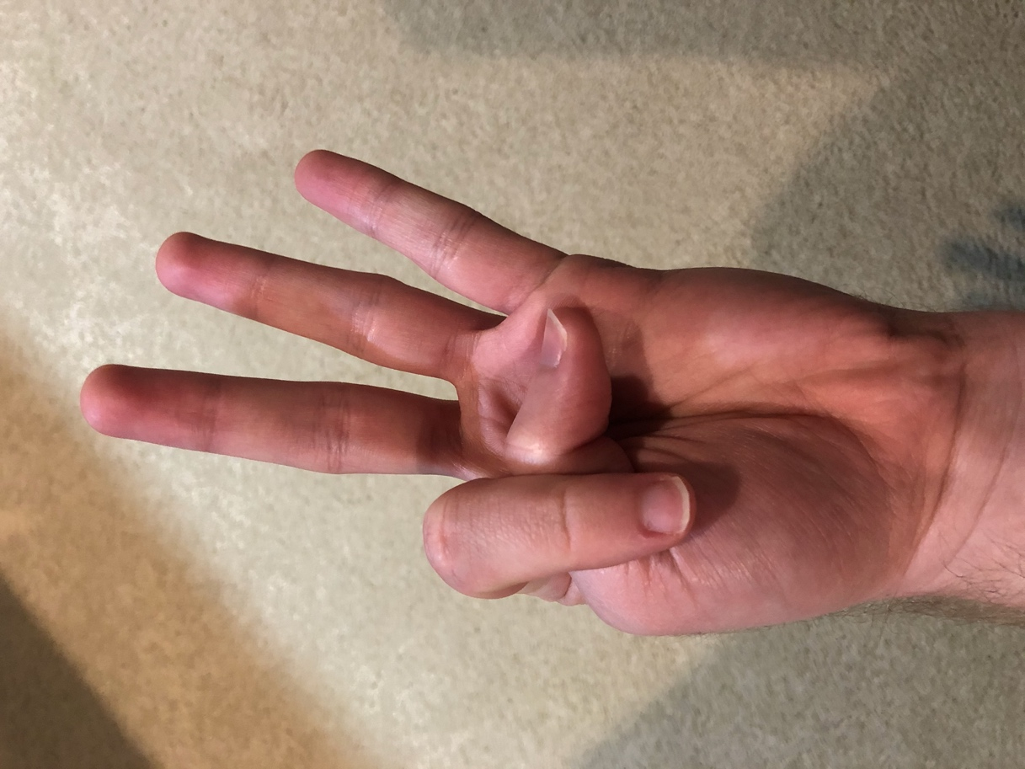
二 - 2
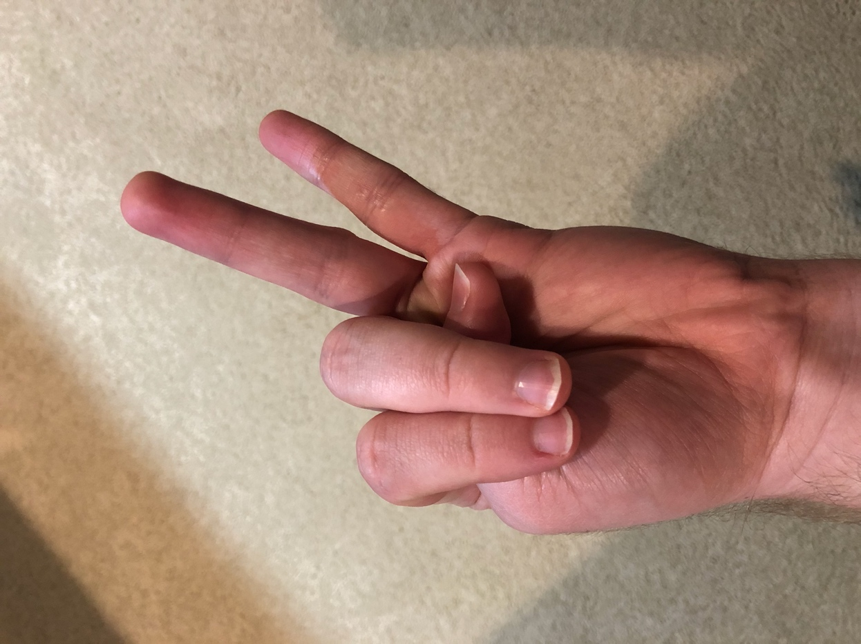
三 - 3
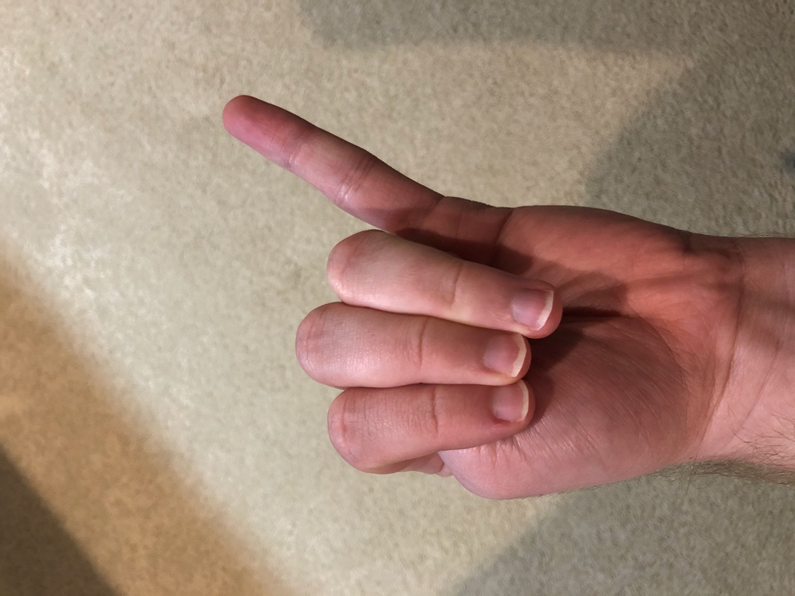
四 - 4
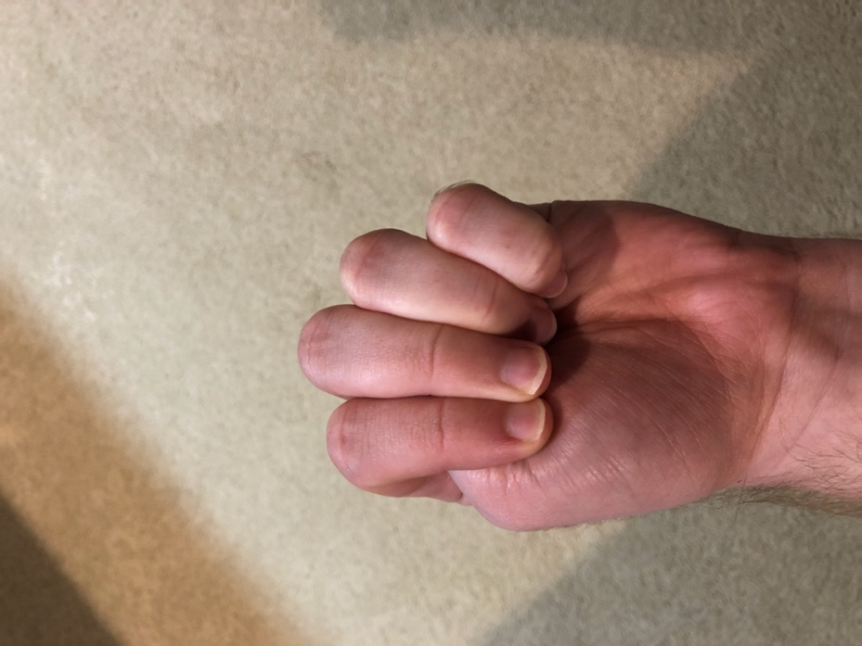
五 - 5

指数え - finger counting

In Japan and many other Asian cultures, finger counting is done in the opposite way from the West. While in the West we begin counting with both fists closed, raising fingers to add numbers, in Japan they start with both hands open and close fingers to add. Start by closing the thumb, then the index finger, middle finger, ring finger, and pinky to count from 1 to 5. Repeat on the other hand to count to 10.

